CREEPY STORY PART FIVE: FIRST PART OF THE CLIMAX
In this section you imagine something that you would find particularly scary. I don’t know what that will be, but here are some guidelines for writing it in a scary way.
Show what you see in the room. At first, don’t make it obviously scary, (no gallons of blood or piles of body parts, etc.)
Perhaps in the half light you see a huddled shape on a bed, in the corner. You whisper, approach, carefully pull back the covers in dread and see……what?
Perhaps it’s a pretty bedroom for a child - pink frilly four-poster bed, the sound of innocent childlike singing coming from it. You pull back the bed-curtain and see the back of a little girl playing with something…what is it? Suddenly you realize it’s a hand, severed, bloody. At that moment she turns around and you see the face. Is it ravaged and twisted by burns, the face of an old crone cackling at you, is it completely blank –no mouth or nose, just blood-shot eyes?
Once you see the horrible thing, whatever you’ve chosen, describe it in vivid detail so your reader can see it, hear it, smell it too.
STOP HERE! THERE IS NO ACTION JUST YET, JUST DESCRIPTION. USE YOUR VERY BEST WRITING HERE! See over the page for a great word bank.
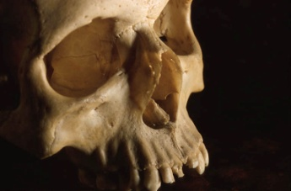
USE THIS WORD BANK FOR THE REST OF THE STORY!
Slimy gruesome devastated ferocious bloody monstrous fleshy stony foggy stabbing slit screech bulbous scarred snaking sliced teeth poking swallow prey motionless shabby rattling choking suffocating loomed knotted gnarled
knife timorous savagely devour throbbing
sticky vicious dripped slithered raked stabbed clawed
hollow snapping sharp death exposed organs grimy
ghoulish ghostly pale cold icy metallic gripped clotted
jagged cracked swollen blistered lifeless glazed
trembling gaping splattered gurgling gasping groaning
ravaged sneaking stumbling sprawled groping psychotic
raving slobbering moaning whimpering begging pleading
lunged freakishly softly silently desperately
sluggishly slippery smashed collided gash gory putrid
stench insane raving murderous glazed pale deathly

